## Selection preview

Any objects that have been highlighted in the selection box will be highlighted in green, indicating what you have selected.

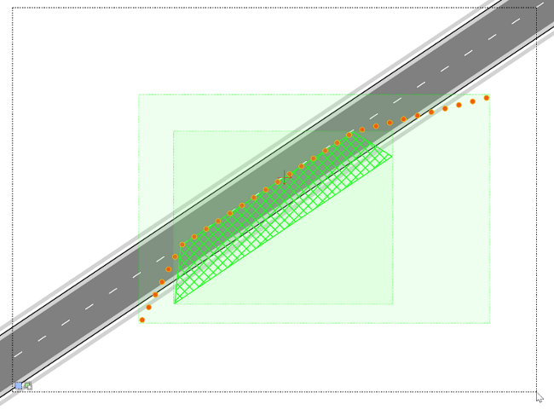

Selection_Preview_Box

The below are the available selection modes when selecting objects:

**Selection modes** Selection1 New selection (default) Selection2 Add to selection (hold Shift key) Selection3 Remove from selection (hold Alt key)

**Capture modes** Capture1 Contained objects (default) Capture2 Intersecting objects (use right mouse button)